Project Design Phase-II
Data Flow Diagram & User Stories
Date | 30 September 2026
Team ID | SWTID-2026-8157
Project Name | BlogNest – AI-Powered Blog Content Generation & Management Platform
Maximum Marks | 4 Marks

Data Flow Diagrams:
A Data Flow Diagram (DFD) is a visual representation of the information flows within a system. It shows how data enters and leaves BlogNest, what changes the information, and where data is stored.
Level 0
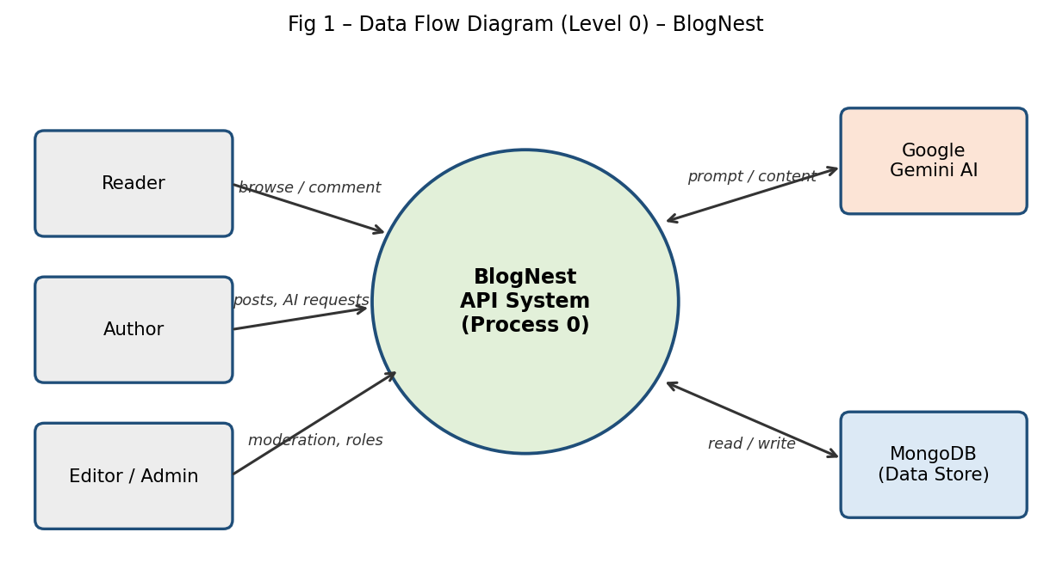
Level 1
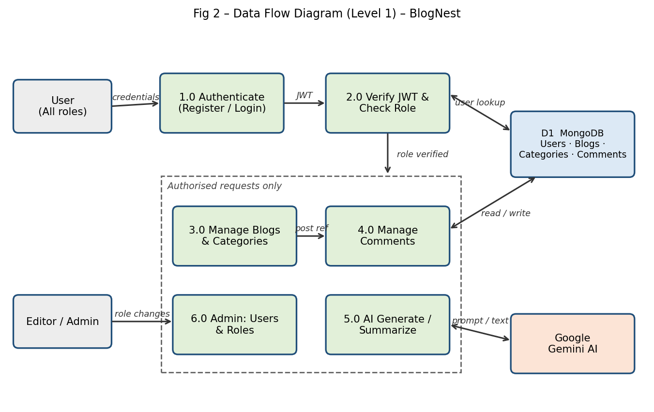
User Stories
The table below lists the user stories for BlogNest.
User Type | Functional Requirement (Epic) | User Story Number | User Story / Task | Acceptance criteria | Priority | Release
Reader | Registration & Login | USN-1 | As a reader, I can register by entering my name, email and password. | Account is created and I receive a success response (201) | High | Sprint-1
 |  | USN-2 | As a reader, I can log in with my email and password. | I receive a JWT token; wrong password returns 401 | High | Sprint-1
 | Reading | USN-3 | As a reader, I can browse published blog posts. | GET /api/blogs returns the list of posts (200) | High | Sprint-2
 | Comments | USN-4 | As a reader, I can comment on a post. | My comment is saved with a pending status and linked to me and the post | Medium | Sprint-2
Author | Blog Management | USN-5 | As an author, I can create, edit and delete my own blog posts. | Post is saved under my account; I cannot modify others’ posts | High | Sprint-2
 | AI Generation | USN-6 | As an author, I can generate a blog draft from a topic and category. | AI-generated title and content are returned (201) | High | Sprint-2
 | AI Summary | USN-7 | As an author, I can summarize long content. | A concise summary is returned (200) | Medium | Sprint-2
Editor | Content Review | USN-8 | As an editor, I can review pending posts and change their publishing status. | Status changes to published / scheduled and is visible to readers | High | Sprint-2
 | Moderation | USN-9 | As an editor, I can approve or mark comments as spam. | Comment status updates to approved / pending / spam | Medium | Sprint-2
Administrator | User Management | USN-10 | As an admin, I can manage user accounts and assign roles. | Role change takes effect on the next request; non-admins get 403 | High | Sprint-2
 | Security | USN-11 | As an admin, I want unauthenticated and unauthorized requests blocked. | Missing or invalid token returns 401; wrong role returns 403 | High | Sprint-2

